
- Home
- About Us
- Products & Services
- How We Work
- Contact Us
- Download

Request for Quotation
Get Demo



We love to talk with you about our Services

How we work

Exclusive Project & Team management



Customer Relationship


Better Understanding


Cost Effective


Timely Delivery


Quality Assurance


Reliability & Commitment


Dedicated customer support
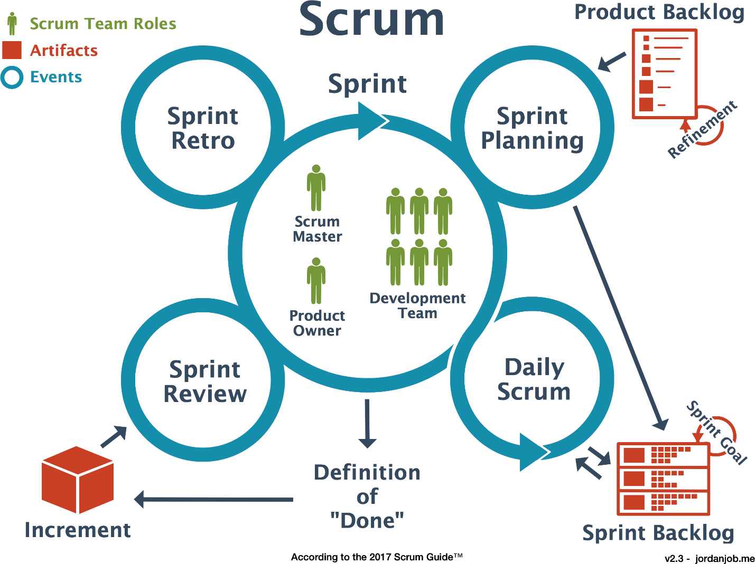

We always belive in a quality
Our commitment to quality is unmatched - providing the best products and services to our customers.


Hardware solution
Power up your technology with our advanced hardware solutions - designed to meet your specific needs
Explore


Software solution
Transform your business with our custom-built software solutions - designed to meet your specific needs
Explore


Data center Solution
Elevate your data security to the next level with our secure data center solutions
Explore


Managed Services
Achieve greater success with our fully managed services - designed to meet your specific needs
Explore


Security & Surveillance
Keep an eye on your assets with our comprehensive security and surveillance solutions
Explore


Customize ERP Solutions
Transform your business with our fully customizable ERP solutions - designed to meet your specific needs
Explore


With a mission to deliver Excellence, through Innovation in designing solutions, implementing those in an innovative way using the right technologies. Pakiza Technovation Limited is the newest concern of renowned Pakiza Group, the standard of excellence in all its business sectors. Pakiza Technovation Limited always love to optimize, not to be lowest price, its solution to meet its client’s requirement & thus ensure value for money.

Address
Head office : House# 97, Road# 11/A,
Dhanmondi, Dhaka-1209, Bangladesh
+880 9612 811 111
info@pakizatvl.com
Registered office: Khordo Nowpara,Rasulpur Narsingdi (Sadar), Narsingdi-1600, Bangladesh

Get Connected

App privacy and policy


© 2023 Pakiza Technovation Limited

